LAB ASSIGNMENT-14

Name : k. Sushanth

h.no:2403a51348

batch:14

Task 1: Create a Responsive Web Page Layout

Code:

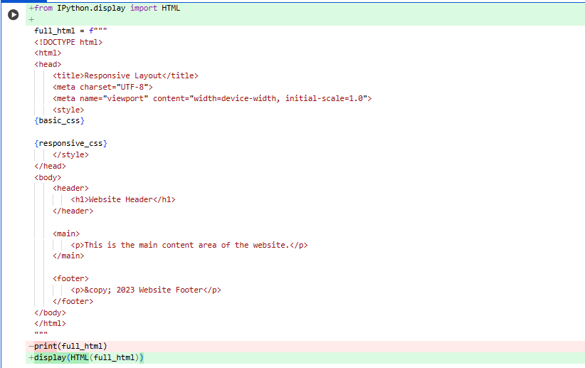

OUTPUT:

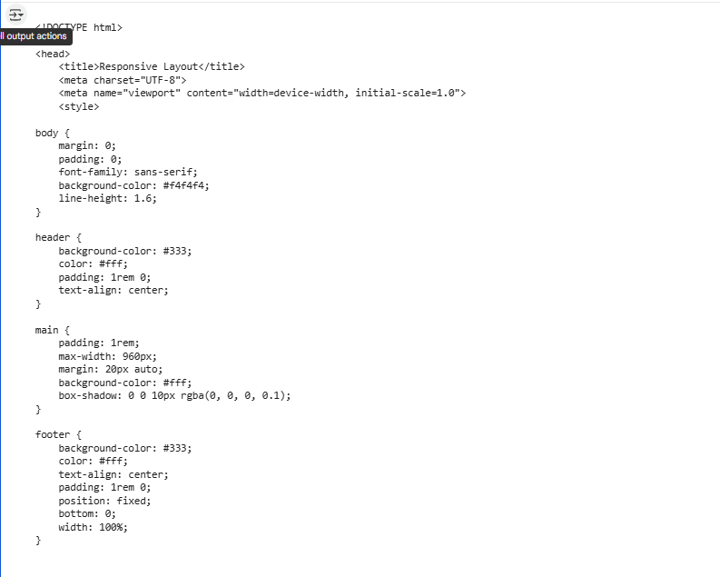

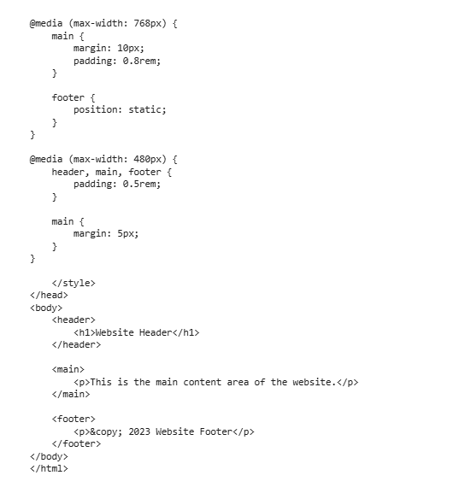

OBSERVATION:

1.Use a **flexible grid layout** with CSS Grid or Flexbox.

2.Apply **media queries** to adapt styles for different screen sizes.

3.Ensure **images and text scale** fluidly using relative units.

4.Design **mobile-first** for better performance and usability.

5.Test responsiveness across devices and check for **readability, navigation, and load speed**.

Task 2: Interactive Button with JavaScript

Code:

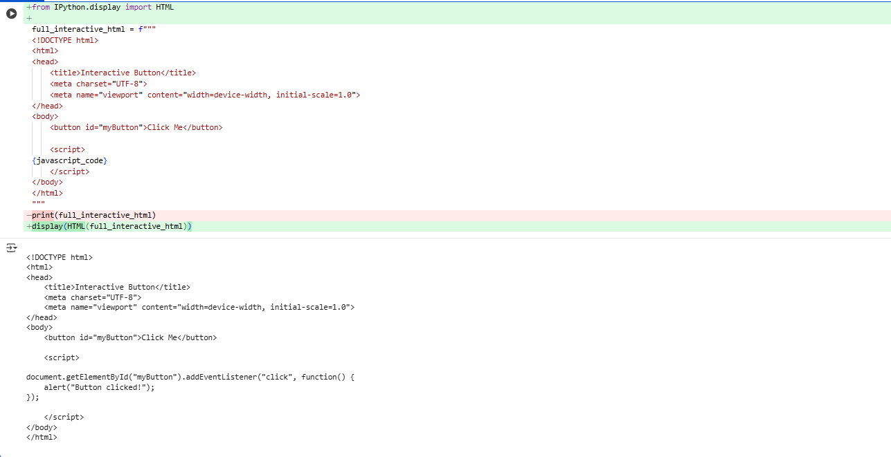

Output:



Observation:

1. The button responds dynamically to user clicks, enhancing interactivity.
2. JavaScript toggles both the button's label and background color.
3. Event listeners are used to detect and handle user actions.
4. Inline styling changes provide immediate visual feedback.
5. The logic is simple yet effective for demonstrating DOM manipulation.

Task 3: Form with Validation

Code:

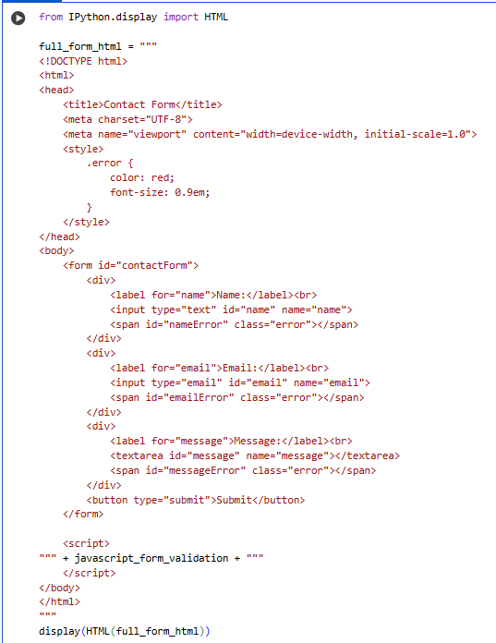

Output:

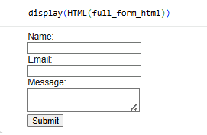

Observation:

1. The form includes essential fields: Name, Email, and Message.
2. JavaScript ensures all fields are filled before submission.
3. Email format is validated using a regular expression.
4. Inline error messages guide users to correct input mistakes.
5. The form prevents submission until all validations pass.

Task 4: Dynamic Content Generation

Code:

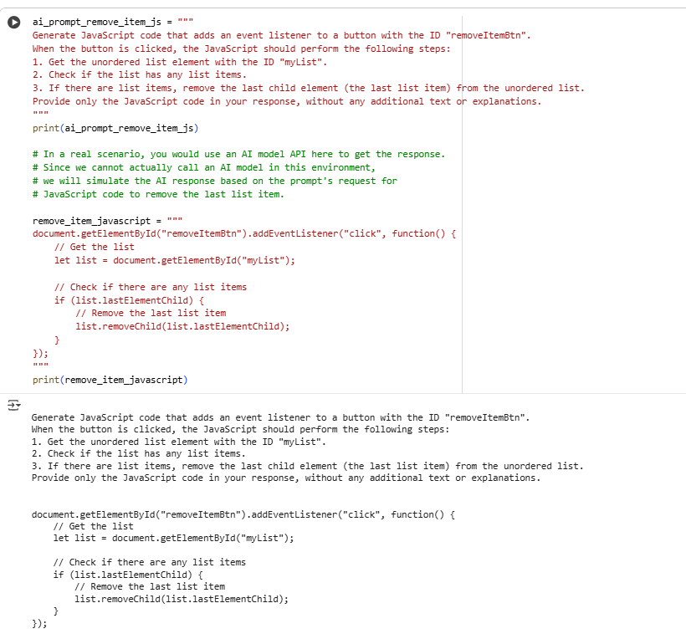

Output:



Observation:

1. The initial product list is created using standard HTML and elements.

2.JavaScript functions allow users to add new items or remove the last item interactively.

3.Input validation ensures empty entries are not added to the list.

4.DOM manipulation is used to update the list in real time.

5.Alerts provide feedback when actions are invalid, enhancing user experience.

Task 5: Styled Modal Popup

Code:

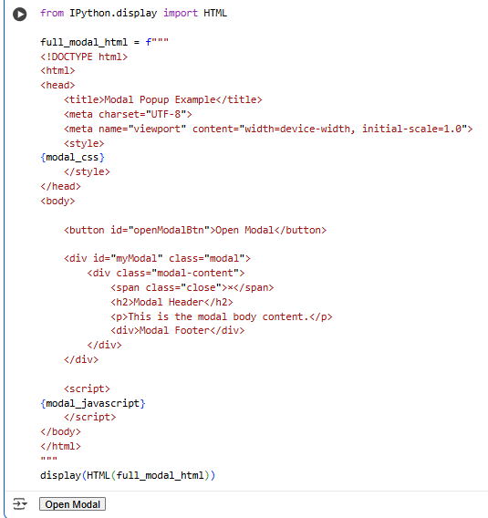

Output:



Observation:

1. The modal uses a semi-transparent overlay (rgba(0, 0, 0, 0.5)) to dim the background and focus attention.
2. It is triggered by a button click, toggling the modal's visibility via JavaScript.
3. The modal content is centered using Flexbox and styled with padding and rounded corners.
4. A close button (×) allows users to dismiss the modal, enhancing usability.
5. Clicking outside the modal content also closes it, improving user experience.